pdfgfy e08f/L
sdn ebf} &
;z:q k|x/Låf/f $ nfv ?k}ofF a/fa/sf] cj}w ;fdfg a/fdb
;z:q k|x/L an g]kfnn] cfh r]shfFr tyf u:tLsf qmddf sl/a $ nfv ?k}ofF a/fa/sf] cj}w ;fdfg a/fdb u/]sf] 5 .
;z:q k|x/L g]kfn g+ #* l/hj{ u0f af6 ;z:q k|x/L pkl/Ifs lbg]z s'df/ a:g]tsf] sdf08df vl6Psf] 6f]lnn] ljz]if ;"rgfsf cfwf/df k'j{ klZrd /fhdfu{df r]shfFr ug]{ qmddf cj}w ;fdfg a/fdb u/]sf] xf] .
j/fdb ul/Psf ;fdfgdf nQfsk8f /x]sf]n] ;f] ;fdfg d]lr eG;f/ sfo{fnodf a'emfPsf] k|x/L pkl/Ifs lbg]z s'df/ a:g]tn] hfgsf/L lbg'eof] .
kl5Nnf] ;do ;Ldf If]qdf af6 rf8kj{nfO{ nlIft u/]/ cj}w ;fdfg cf];f/k;f/, rf]/L t:s/L tyf u}/sfg'gL ultljlwx'g] ePsf]n] To;nfO{ Go'lgs/0f lgoGq0fsf nflu lgu/fgL / u:tLnfO{ tLj|tf lbFb} cfPsf] k|x/Ln] hgfPsf] 5 .

pdfgfy e08f/L
sdn ,h]7 !)
sdn . emfkfsf] sdn ufpFkflnsfdf kflnsf :tl/o ehg ufog k|ltof]lutf ;DkGg ePsf] 5 .
>L ehg sLt{g d08nL sdn ufpF sfo{;ldlt emfkfsf] cfof]hgfdf lqlbj;Lo P]ltxfl;s ehg sLt{g ;Dd]ng tyf kflnsf :t/Lo ehg ufog k|ltof]lutf ;DkGg ePsf] xf] .
sdn ufpFkflnsfdf /x]sf sl/a ! ;o #& j6f sLt{g kl/jf/ dWo] $! j6f sLt{g d08nL ;xefuL ePsf lyP . ;xefuL dWo] !^ j6f sLt{g ;d'xn] klxnf] r/0f kf/ ub}{ kmfO{gndf k|j]z ug{ ;kmn ePsf lyP .
kmfO{gn k|j]z u/]sf sLt{g d08nL dWo] ufog k|ltof]lutf tkm{ sdn $ l:yt l;4fy{xl/ sLt{g d08nL k|yd, sdn # l:yt /fwfs[i0f slt{g d08nL ålto tyf sdn @ l:yt nIdLgf/fo0f sLt{g d08nL t[lto / sdn # s} kflye/f slt{g d08nL / sdn % l:yt dftf kflye/f sLt{g d08nL ;fGTjgf zfGTjgf :yfg xfFl;n ug{ ;kmn ePsf] lg0f{os ;ldltsf ;+of]hs s}nfz yfkf du/n] hfgsf/L lbg'eof] .
ljh]tf sLt{g kl/jf/nfO{ qmdz & xhf/ , % xhf/ @ xhf/ / PsPs xhf/ gub ;lxt k|df0f kq k|bfg ul/Psf] lyof] . To:t} pTs[i6 e]ife'iff tkm{ sdn # l:yt l;+xb]jL sLt{g d08nL k|yd sdn % / ^ l:yt uLtf~hln sLt{g d08nL ålto tyf sdn $ l:yt l;4b]jL sLt{g d08nL t[lto ePsf] lg0ff{os ;ldlt ;+of]hs yfkfn] hfgsf/L lb'eof] .
To:t} pTs[i6 k|ltj]bg k]z ug]{ sLt{g kl/jf/ tkm{ sdn ^ l:yt k'ikf~hnL sLt{g d08nL k|yd sdn # l:yt nlIdgf/fo0f sLt{g d08nL ålto tyf sdn % l:yt h]i7 gful/s sLt{g d08nL t[lto ePsf >L ehg sLt{g d08nL sdn ufpF sfo{;ldltsf n]vf ;ldlt ;+of]hs kml0fGb| u8tf}nfn] hfgsf/L lbg'eof] .
e]ife'iff tyf k|ltj]bg tkm{ k|yd ålto / t[lto x'g]n] qmdz @ xhf/ ! xhf/ % ;o / ! xhf/ gub ;lxt k|df0f kq åf/f k'/:s[t ul/Psf] ;ldltsf ;b:o ;Gtf]; ;fksf]6fn] atfpg' eof] .
a}lås ;gftg wd{nfO{ ;+/If0f ub}{ ehg sLt{g dfkm{t ;Eo ;dfh lgdf{0f ug]{ pB]Zon] k|ltof]lutf cfof]hgf ug'{sf ;fy} eflj k':tfnfO{ ;gftg wd{sf af/]df hfgsf/L u/fpb} nf]k x'b} uPsf] ;+:sf/ ;+:s[tLsf jf/]df ;d]t o'jfnfO{ ;r]tgf hufpgsfnfuL sfo{qmd cfof]hgf ul/Psf] >L ehg sLt{g d08nLsf s]lGb|o cWoIf aneb| l;jfsf]6Ln] atfpg' eof]
jfO{6=== aneb| l;jfsf]6L÷cWoIf÷>L x/L ehg sLt{g d08nL ,s]lGb|o ;ldlt
gofF k':tfnfO{ wd{;+s[tLsf af/]df ;r]tgf hufpg'sf ;fy} . ufpFkflnsf leq /x]sf sLt{g d08nLnfO{ ;+ul7t ub}{ df}lns ehg sLt{g dfkm{t ;dfhnfO{ ;';'lrt ug]{ pB]Zosf ;fy sfo{qmd cfof]hgf ul/Psf] >L ehg sLt{g d08nL sdn ufpF sfo{;ldltsf cWoIf xl/ uh'/]nn] atfpg' eof] .
jfO{6===== xl/ uh'/]n÷ cWoIf ÷>L ehg sLt{g d08nL, sdn ufpF sfo{;ldlt
sdndf o:tf] dxTjk'0f{ sfo{qmddf e'tk:jL j[Gbf a/fnn]

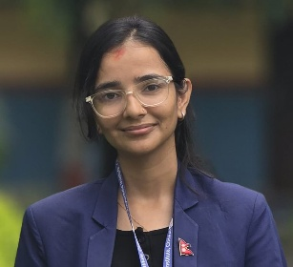
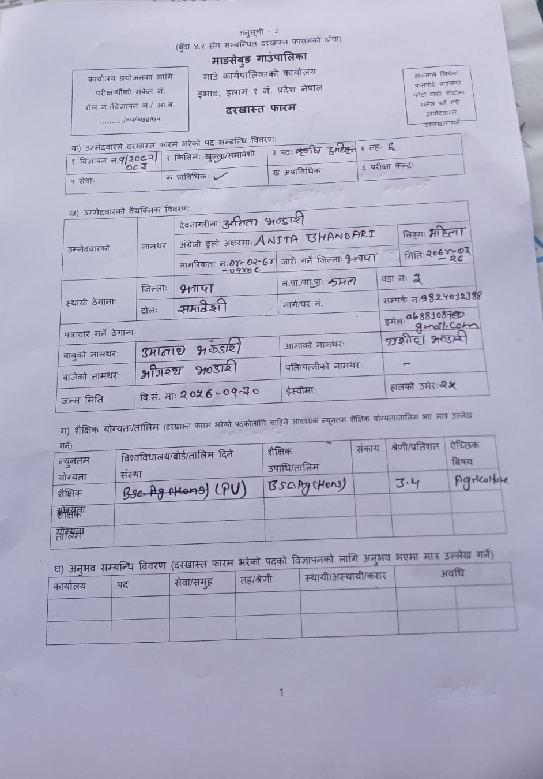
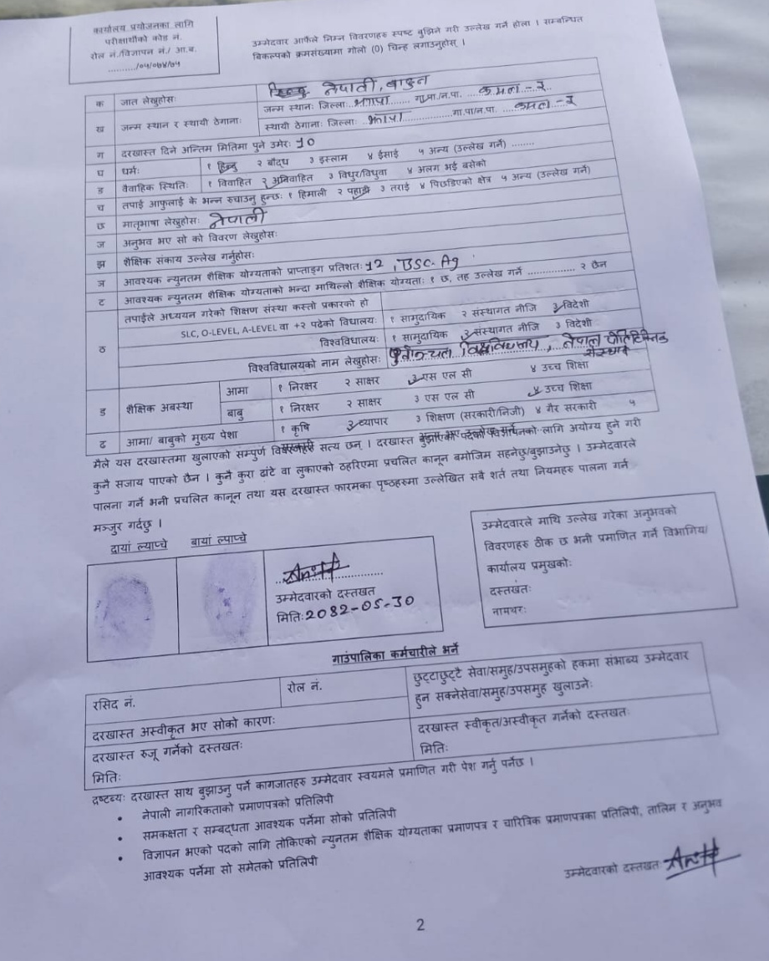
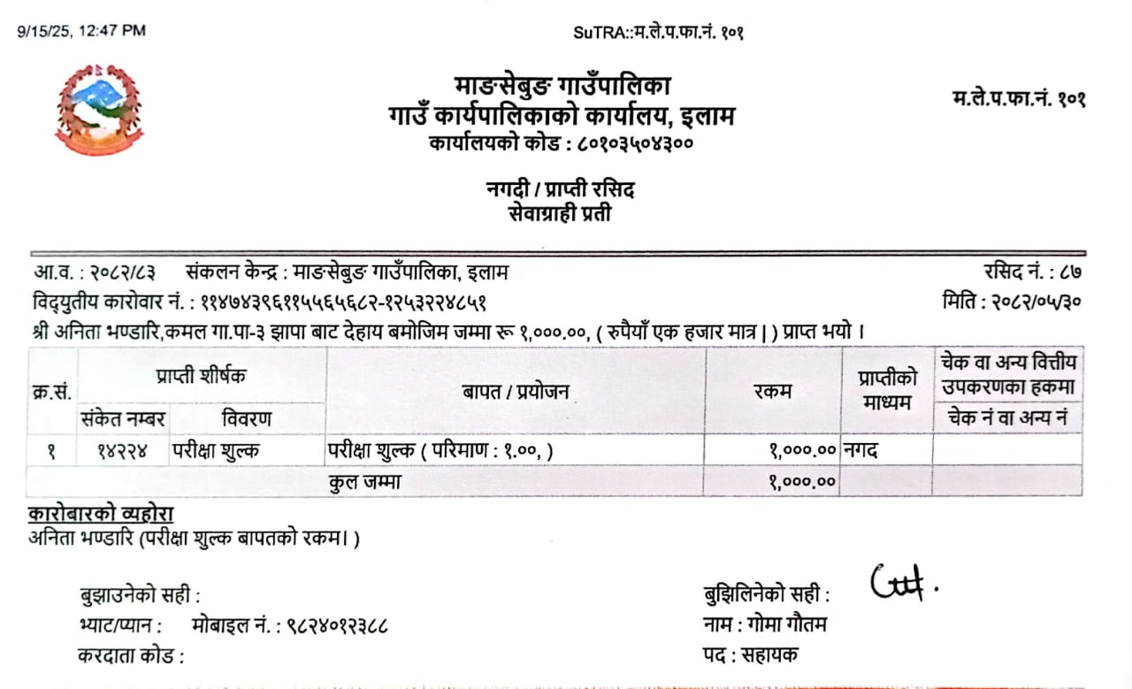

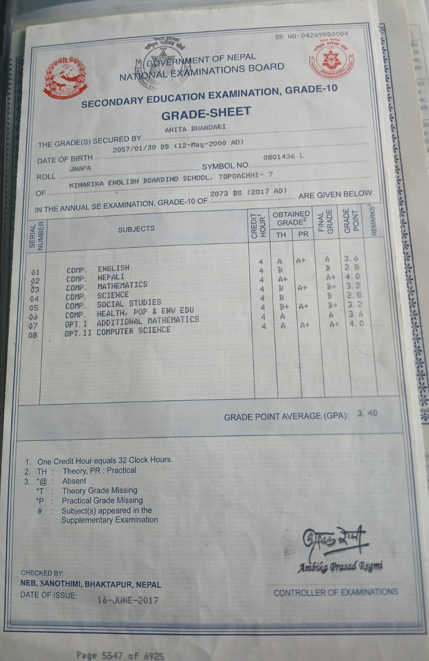
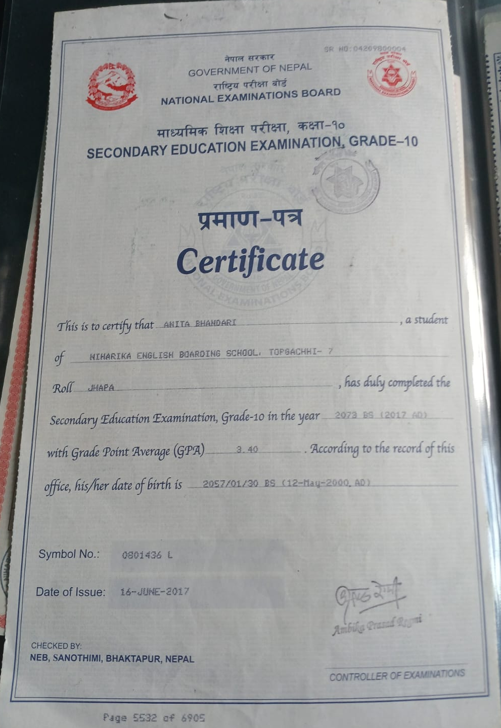
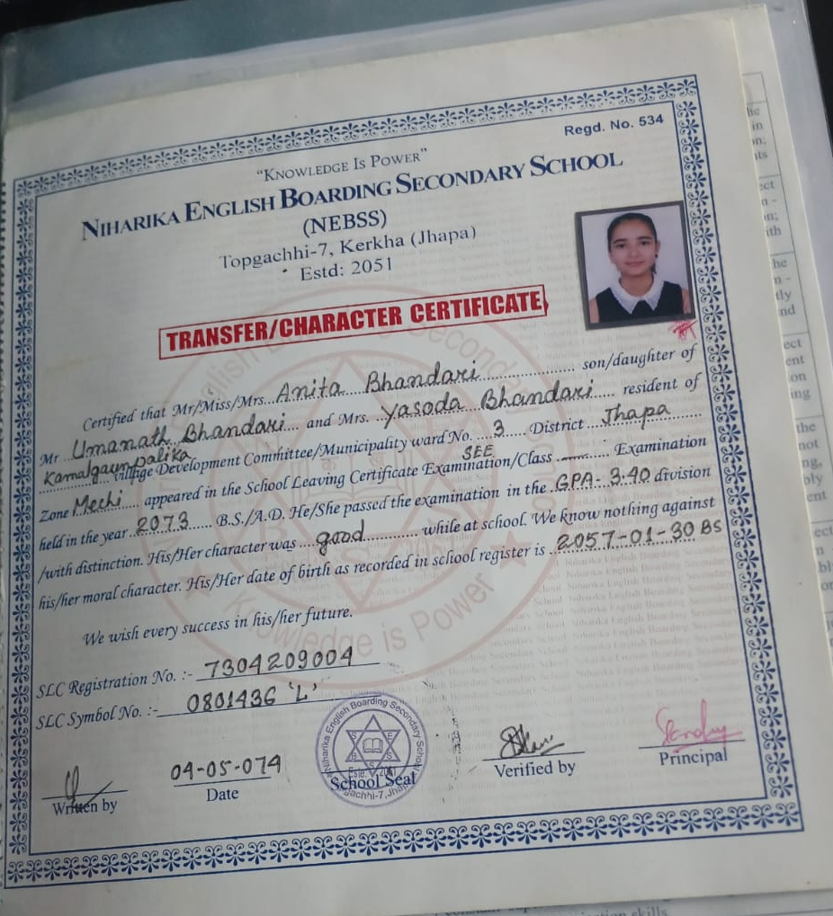

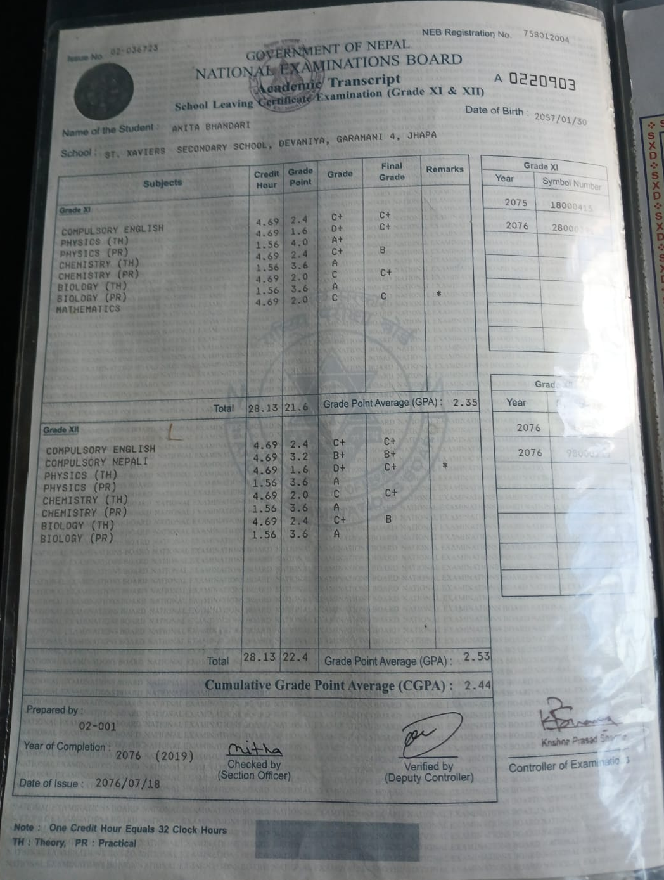

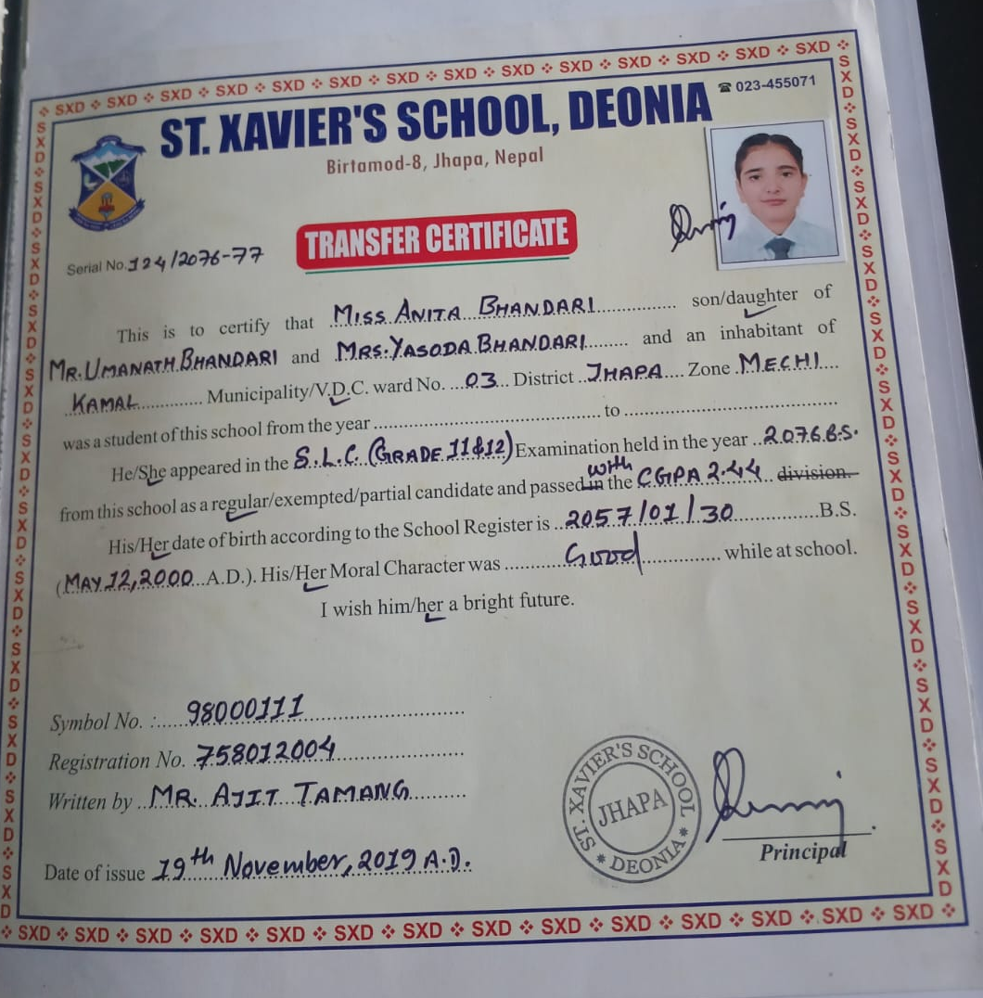

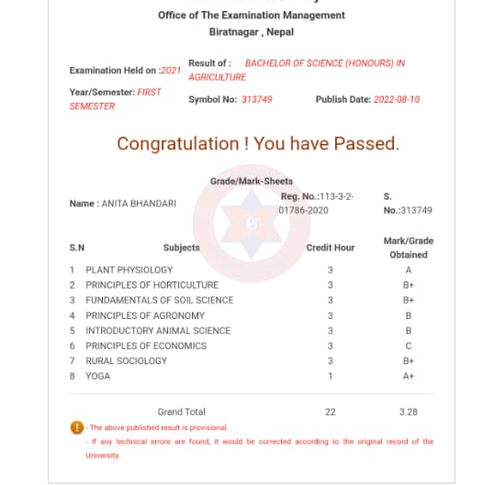

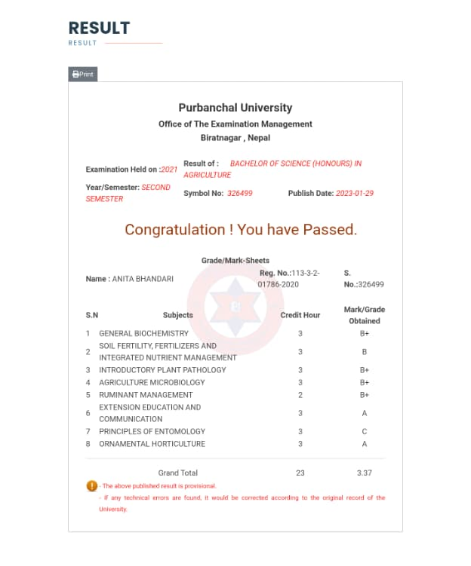

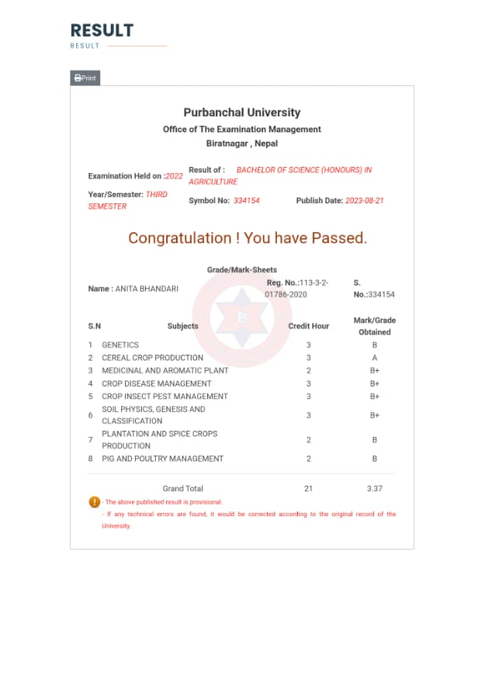

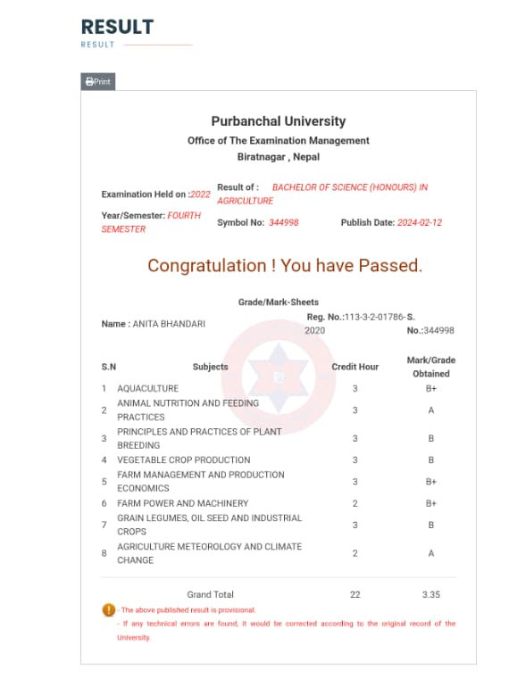

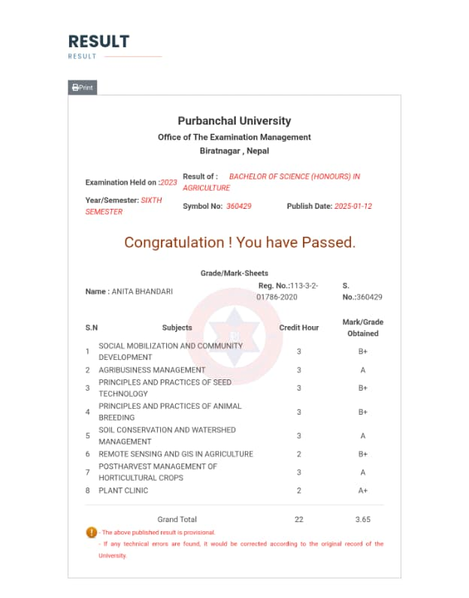

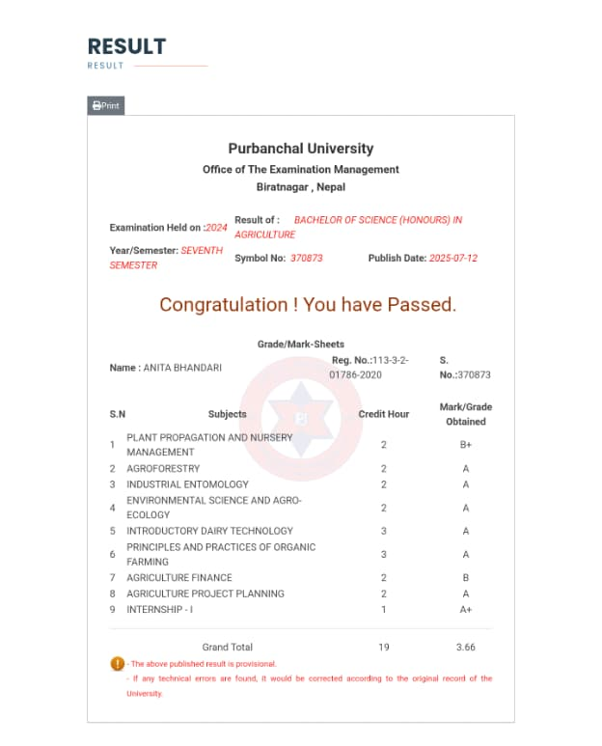

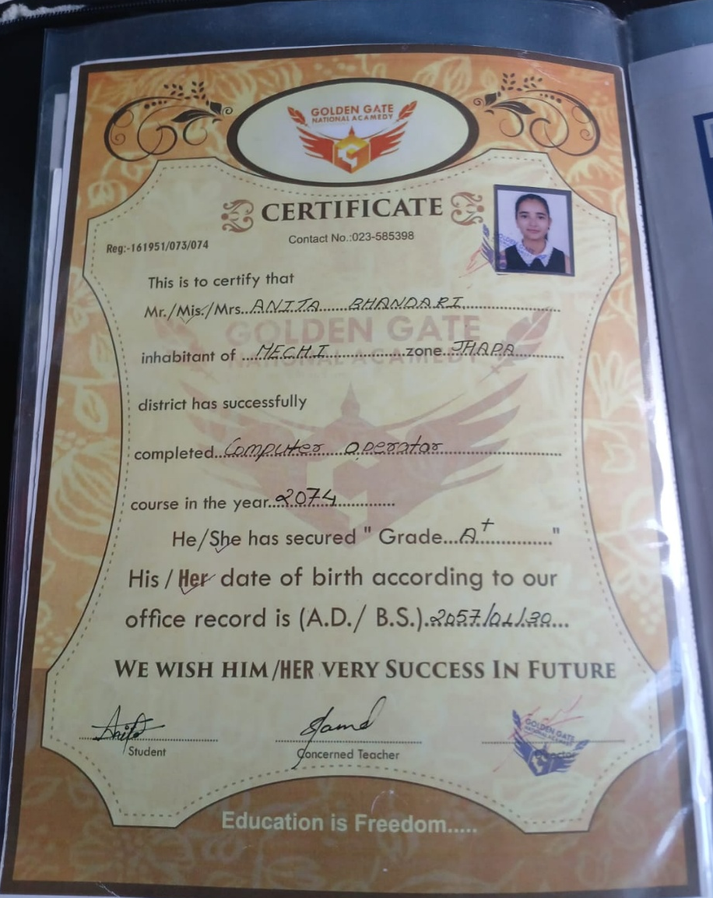

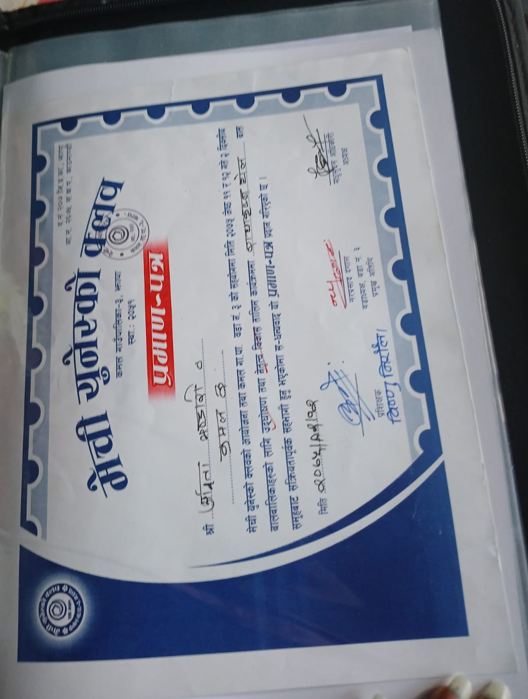

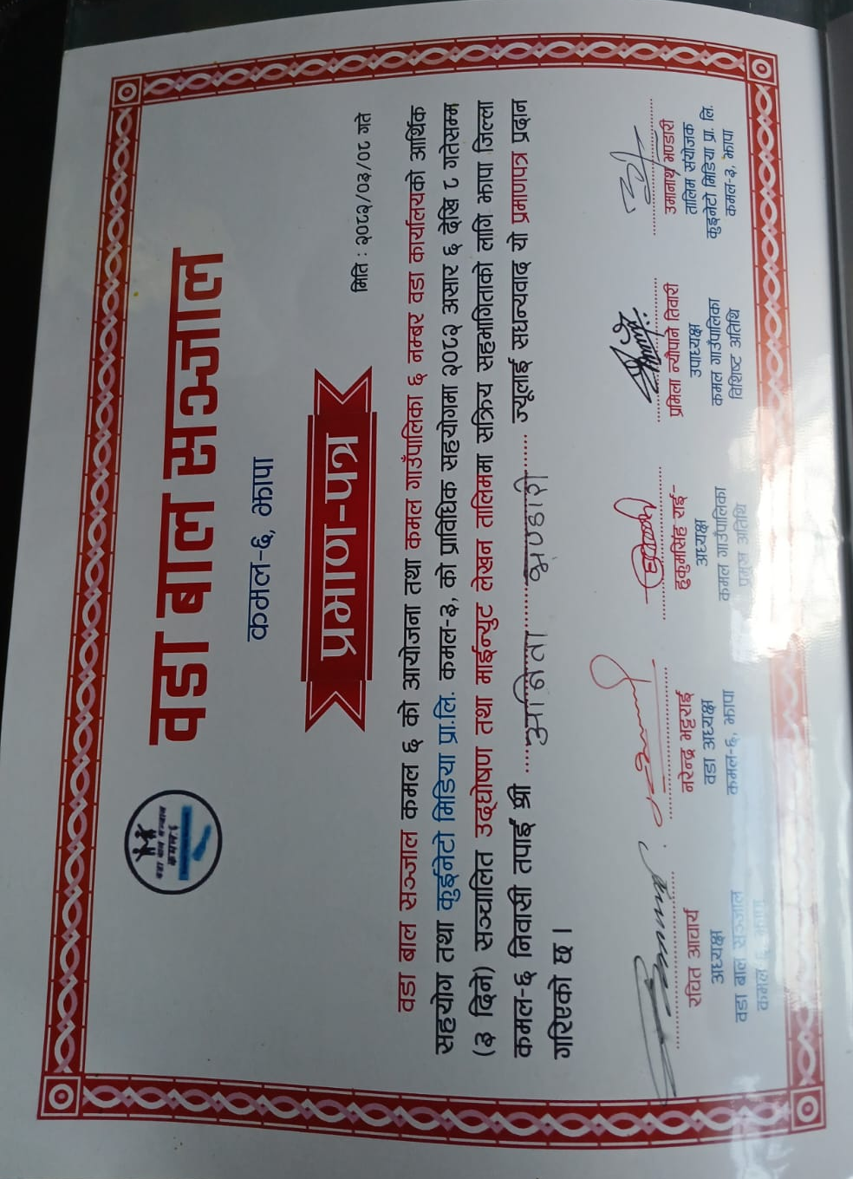
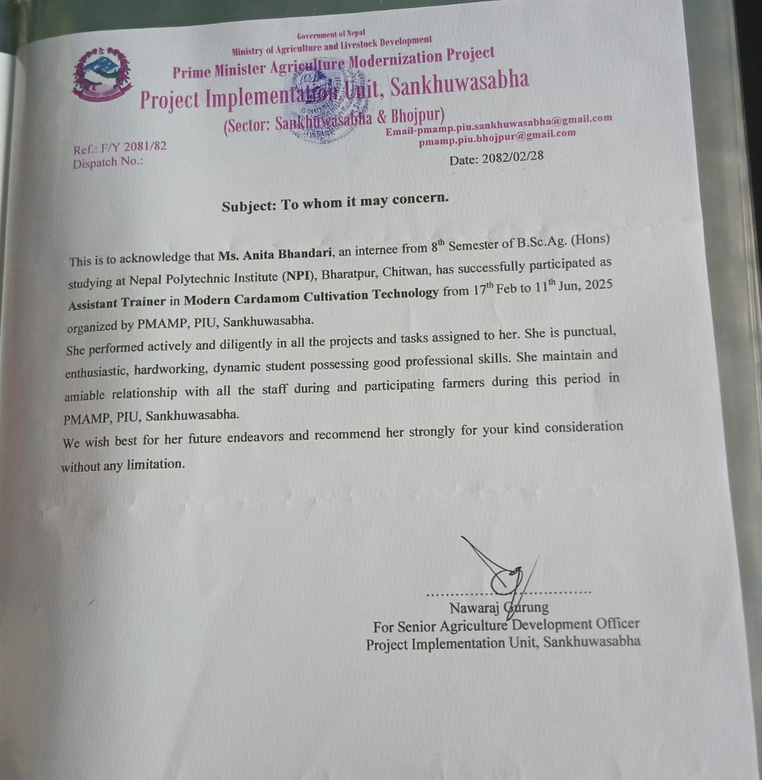
CURRICULUM VITAE
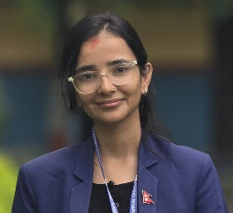
ANITA BHANDARI
Graduated Students
Nepal Polytechnic Institute (NPI)
Bharatpur-11, Chitwan, Nepal
Phone Number: +977- 9824012388
Email: ab881087@gmail.com

PROFILE
Extremely motivated and passionate agriculture students pursuing opportunity which will allow me to grow professionally, Intellectually, morally and emotionally in new environment, while effectively utilizing my study and work experience to expand my understanding of discipline that I have chosen.

PERSONAL INFROMATION
Address: Kamal-3, Kerkha, Jhapa, Nepal
Date of Birth: 12/05/2000 Age: 25 Gender: Female
Father Name: Umanath Bhandari
Mother Name: Yasoda Bhandari
Nationality: Nepalese
Marital Status: Single
Level\Degree | School\College\University | Passed Year (AD) | GPA
SEE | Niharika English Boarding Secondary school (NEBSS) | 2016 | 3.40
SLC | St. Xavier’s School | 2019 | 2.44
Bachelors | Nepal Polytechnic Institute | 2025 | 3.40
EDUCATIONAL QUALIFICATIONS

SKILLS & EXPERIENCE
- Good in Written and communication(verbal) skills in Nepali, English and Hindi Language, Punctual, Able to guide students properly.
- Knowledge on Agriculture related activities.
- Computer Skills: MS-Word, Excel, Power point, Emails, Google drives.
- Agriculture Research &Survey Data Analysis Using Excel, SPSS & R-Studio.

